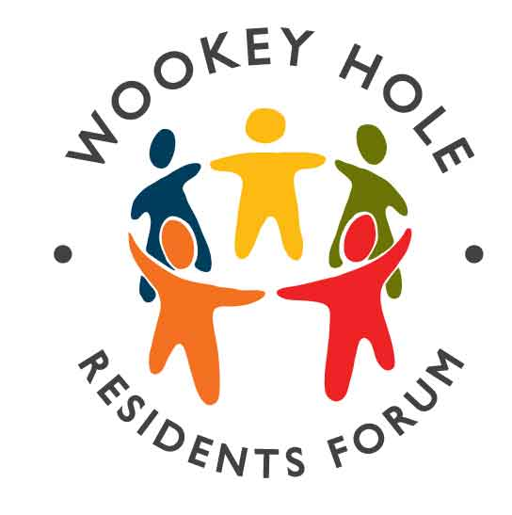
Wookey Hole Residents’ Forum
Committee Meeting, Wookey Hole Club Thursday 5th October 2017. 7.30pm

In attendance: Hugh Talbott (Chair), Nicky Amos, John Grange, Mary Gaunt. Observer: - Councillor David Ball. Apologies Roger Hancock, Jenny Lewis, Louise Burton, Julia Scarth, David Scarth, Gary Amos. James Lewis. (Note: Quorum is 5)

1. Minutes of the committee meeting 1st June 2017 were agreed and signed by the Chair.
2. Matters Arising. Nicky has delivered information flyers and a copy of WH What’s On to the new houses on the Thales site. Three people have asked to join the WHRF mailing list. Please tell Nicky if there are any new residents in the village so she can put something through their letterbox. Committee member Dave Hudsmith has tendered his resignation from the committee due to other commitments.
3. Treasurer’s Report. Opening balance is £1,395 of which £520 is held on behalf of the Neighbourhood Plan group. The Cream tea walk made £16.30 profit. New balance is £1,411.30. John to contact Roger regarding payment of 2018 web-hosting fees.
4. EVENTS FEEDBACK
Cream Tea walk 25th June. The Geology/ Cream Tea walk led by Dr Doug Robinson starting at Chesham House and ending for cream tea at the Community Hall was very successful. Roger, Julia and Doug thanked for organising this excellent event.
St Cuthbert’s Mill Visit 25th September. Many thanks to Julia for arranging these visits, (we were shown around in groups of 5), which were very informative and enjoyed by all. Also many thanks for liaising with the Mill and thanking them afterwards.
2018 Events It was decided to hold a Bring and Share Supper on Saturday 20th January (note, last years event started at 6pm on a Friday which was too early, so this year we will make it a bit later and on a Saturday).
We will hold the WHRF AGM on Thursday 19th April 2018 at 8pm.
5. Update from Working Groups - see overleaf.
6. ANY OTHER BUSINESS
Land at Glencot. Councillor Ball advised that the Parish Council working party have recommended that the number of allotments available be increased by 6 using the currently unused land at the south-east corner of the site. Sadly the sale of the pony-paddock land to Mr Harris has still not been finalised.
Agenda and Minute Secretary. Nicky will ask the ‘mailing list’ whether there is someone who can handle this role as she has commitments in 2018. Nicky can continue to handle the mailing list and mailing list e-mails.
New Committee Members. Sarah Britton and Doug Robinson have expressed an interest in joining the committee and will come to the next meeting. Nicky will add their names to the committee mailing list. All other committee members are happy to stand for another term of office.
Neighbourhood Watch. Mary advised that Homestead are interested in a starting a group. David Ball will follow up with Brian and Hilary.
7. The next committee meeting will be on Thursday 7th December 2017 at 7.30pm. at the Wookey Hole Club.

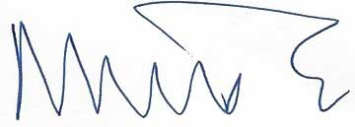 Nicky Amos 8th October 2017

Working Party Reports

The Working Groups reported as follows: -
Village Website John Grange John has found a new hosting company for the village website: the new company charges £56.02 per year rather than the current fee of £169. The web-hosting fee has hitherto been met by SCOPC but it was agreed that this year, WHRF would meet the cost. John advised that the new service is comparable with the old and there should not be any hidden extras.
Neighbourhood Plan David Ball Yet again this has stalled. Mat Gilson the Parish Councillor responsible for the NP for SCOPC now has other commitments and funding for the Housing Needs Surveys for Wells and SCOPC, which are a prerequisite to the NP, is so far not forthcoming. The committee expressed exasperation that after spending so much time on this for North Ward the project is still so far from fruition, notwithstanding that a NP would be essential if a large planning application was put forward for Wookey Hole. David and Mary will take up our frustrations with the SCOPC clerk.
Buses + Footpaths Mary Gaunt The footpaths are being well looked after by local residents armed with secateurs. There has been a change of ownership of the field on the junction of Glencot Lane and Glencot Road and now walkers must keep to the designated mown footpath through the centre of the field rather than using the field edge which has been the habit for some years (thereby avoiding grass ready for mowing).
The new arrangements for the Wookey Hole bus service are working well and usage is good. Mary is campaigning for the bus to stop, as previously, at the Market Place in Wells. Mary was thanked for her work on the retention of our bus service.
Community Garden Scheme Julia Scarth by e-mail. The new vicar, Sam Denyer, is supportive of the Community Garden Scheme and keen to get things moving. Three quotes have been received for the treework needed and a decision will be made at the PCC meeting on 20th October. Churchwarden, David Scarth, has applied for planning permission from MDC for the access work and also submitted a faculty request to the Diocesan authorities. Grant funding is being sought. The architect the group had been using at B2 has resigned, a replacement has been appointed but this is causing hold-ups and frustration.
New Post Box Hugh Talbott Hugh will chase James Heappey again about this as no progress seems to have been made.
Dark Skies Gary Amos by e-mail Gary attended the Starlit Skies Alliance conference in Bath, which was informative, and we will circulate the findings regarding wildlife at light at night to the WHRF mailing list. Another astronomy evening will be held as soon as the nights get darker.
Memorial Trees. David Scarth by e-mail. The trees have now been attended too but need new brass plaques. David will bring examples and costs to the next meeting.
End of WWI Commemoration Jim Reeves Jim Reeves was unable to attend the meeting. Nicky suggested that Wells school children may be interested in making a wicker sculpture, which possibly could be filled with items, poems etc remembering the end of WWI, which could be burnt during the evening. Somewhat like the Burning Man Festival in Nevada. Mary and David will take up with SCOPC as it was felt this was a viable project, which could encourage participation by younger members of the community.

Nicky Amos 8th October 2017

